CSA1708-ARTIFICIAL INTELLIGENCE
LAB EXPERIMENTS
Program 1 : Python Program to Solve 8-Puzzle Problem
Aim
To develop a Python program that solves the 8-Puzzle Problem using a search algorithm (such as Breadth-First Search - BFS) to find the shortest sequence of moves from the initial state to the goal state.
Algorithm
1. Represent the puzzle board as a 3×3 matrix (or tuple of tuples) where numbers 1 to 8 represent the numbered tiles and 0 denotes the empty tile.
2. Define the goal state configuration: ((1, 2, 3), (4, 5, 6), (7, 8, 0)).
3. Locate the coordinates of the empty tile (0) in the current state.
4. Generate all valid successor moves by shifting the blank tile Up, Down, Left, or Right within grid bounds.
5. Use Breadth-First Search (BFS) with a First-In-First-Out (FIFO) queue to explore states systematically level by level.
6. Maintain a visited set to record visited states and prevent redundant state exploration.
7. Dequeue a state from the queue; if it matches the goal state, return the complete solution path.
8. For each unvisited successor state, mark it as visited and enqueue it along with the updated path.
9. If the queue is exhausted without reaching the goal state, report that no solution exists.

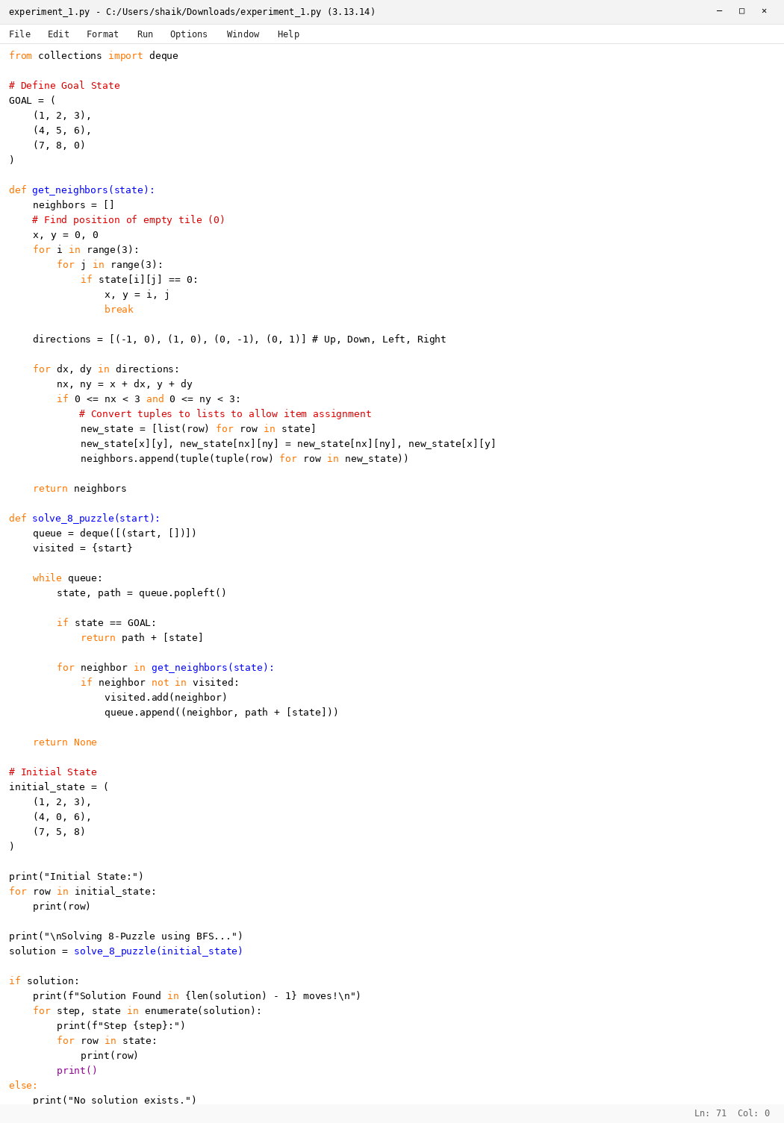

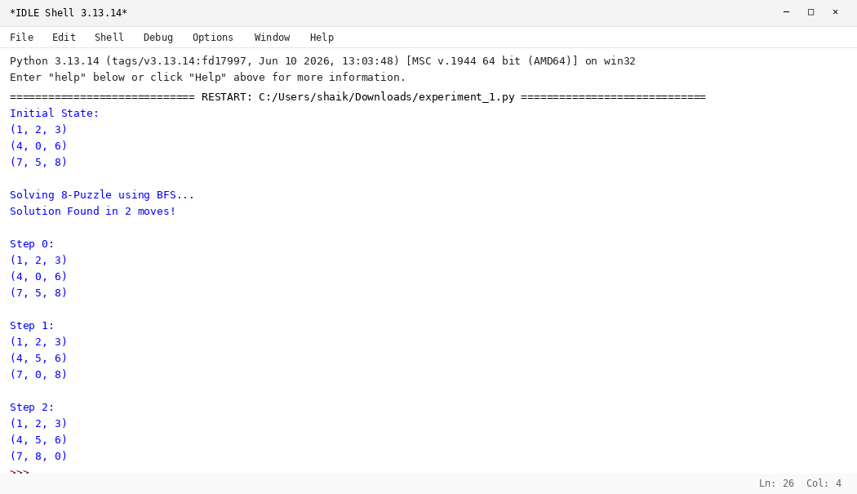

RESULT
Thus, the 8-Puzzle Problem was solved successfully using Python.

